NSWH Data Exchange (Hub) Provider

On-Boarding Guide

Table of Contents

Introduction 2
Terms Used in User Guide 2
On-Boarding Process 3
Stakeholder Responsibilities 3
Timeframe to On-Board to Direct Interface 4
NSW Health Data Exchange (Hub) On-boarding Process 4
Engagement 5
Confirmation 5
Set Up 5
NSW Health Data Exchange Hub Provider 5
Testing 6
Establish Connectivity 6
NSW Health User Acceptance Testing 6
Failed File Submission 7
Example of Failed Invoice Notification 9
Implementation 9
Deactivation of Alternate Submission Methods 9
Further Support 10

Introduction
This guide will assist in the on-boarding process for suppliers to the Data Exchange Hub eInvoicing channel with NSW Health. It is highly recommended that you read and understand all information presented in this document to ensure suitability for your organisation. Integrating this invoice solution will automate the accurate data interchange between supplier to buyer improving processing timelines enabling easier traceability and accountability.

Questions, feedback or suggestions on this document, can be sent to: HSNSW-eInvoicing@health.nsw.gov.au

Terms Used in User Guide
Term | Description
NSWH | New South Wales Health
eInvoicing | Electronic invoicing (also called eInvoicing) is a form of electronic billing. eInvoicing methods are used by trading partners, such as customers and their suppliers, to present and monitor transactional documents between one another and ensure the terms of their trading agreements are being met
AP | Accounts Payable
PO | Purchase Order number
Hub | A Service Provider that provides data and messaging transportation and transformation services et al on behalf of a Vendor and/or a buyer
EDI | EDI (Electronic Data Interchange) is the transfer of data from one computer system to another by standardized message formatting, without the need for human intervention
GLN | Global Location Number
XML Gateway | A component of Oracle’s (NSWH ERP system) application integration framework allowing easy integration to create and consume XML messages.

On-Boarding Process
The on-boarding of a supplier to the NSW Health Data Exchange Hub invoice channel is a collaborative effort between the supplier, Pacific Commerce, and NSWH. Pacific Commerce is responsible for guiding suppliers with the NSW Health file requirements. All parties will be required to complete designated tasks in an agreeable timeframe to ensure a successful and smooth transition. NSW Health will coordinate regular meetings during the lifecycle of the project to ensure momentum towards goals and timeframes are maintained.

Stakeholder Responsibilities
Table 1 outlines the requirements of the supplier, Pacific Commerce, and NSW Health throughout this process.

Table 1
Stage | Supplier | Pacific Commerce | NSW Health
- 1. Engagement | - Engage NSWH for early introductory discussions  - Liaise with Pacific Commerce regarding messaging requirements | - Provide NSWH EDI Invoice guide | - Provide information and support
- 2. Confirmation | - Confirm the transition to the Data Exchange Hub has started  - Provide file notification email address  - Provide key IT contact name & details  - If required, provide details for one pay site and bank account | - Provide NSWH Billing EDI GLN to Supplier | - Record the start of the transition to Data Exchange Hub as the one submission method  - Coordinate the creation of one pay site and bank details for the supplier  - Coordinate delivery of Invoice EDI Location Code with Pacific Commerce
- 3. Set up | - Engage with Pacific Commerce to show the ability to exchange EDI invoice messaging including provision of supplier EDI Trading GLN  - Map EDI Location Codes | - Confirm supplier messaging capabilities  - Mapping of EDI Location Code | - Provide support if needed  - Internal configuration of XML Gateway
- 4. Testing | - Provide test files in line with the requirements of NSWH’s test cases  - Review results from NSWH, if required re-do test files until successful | - Review test files, ensure NSWH requirements are met, provide feedback to both parties  - Successful files transmitted to NSWH test environment | - Provide required test case invoice data  - Test files and provide results
- 5. Implementation | - Agree on a start date  - Disable all unnecessary methods of invoice submission as required by NSWH  - Apply changes in production to initiate EDI Invoice | - Initiate translation object for production system for new supplier | - Agree on a start date  - Advise supplier of other unnecessary submission methods to be disabled  - Record the go-live of the Data Exchange Hub as the one submission method
- 6. Monitoring | - Review NSWH feedback and where possible make the recommended changes  - Monitor the NSWH Supplier Portal for invoice and account updates  - Review and sign off on Readiness Checklist | - Monitor invoice transmission  - Provide automated email to the supplier when an EDI invoice has failed requesting the invoice to be corrected and resent | - Monitor the account and data for the first two weeks for improvement opportunities, provide feedback if needed  - Monitor the account to ensure no other method of submission is utilised  - Finish Readiness Checklist  - Provide Readiness Checklist to supplier

Timeframe to On-Board to Data Exchange (Hub) Interface
This timeframe will be subject to all parties meeting agreed tasks, however the estimate to on-board to the EDI Invoice submission channel is < 12 weeks including a monitoring period after implementation. This is outlined in Table 2.

Table 2
Week  Stage | 1 | 2 | 3 | 4 | 5 | 6 | 7 | 8 | 9 | 10 | 11 | 12
- Engagement
- Confirmation
- Set up
- Testing
- Implementation
- Monitoring

NSW Health Data Exchange (Hub) On-boarding Process
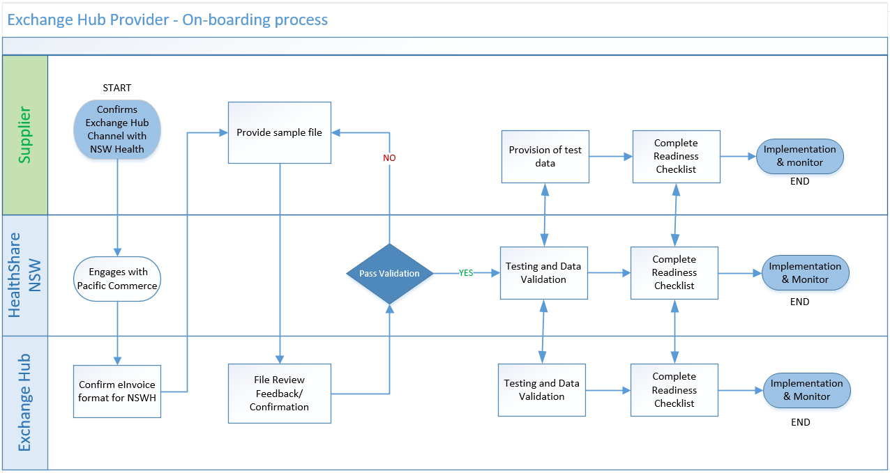

Engagement
During this time it is important to consider if the Direct Interface channel is suitable and achievable for your organisation. The end to end process, and this on-boarding guide will be explained, including the complete technical specifications and on-boarding requirements.

Confirmation
The supplier must confirm their commitment to transition to the Direct Interface channel in an email containing;

- An email address for file notifications: this will be where notifications are sent when an invoice submission fails.
- A timeframe to build the report/file: used to discuss the process timeline
- Key IT contact name and details: this will be the person that NSWH liaises with throughout the IT components of the on-boarding process.

Once received, the above confirmation and details will be recorded by NSWH.

Set Up

NSW Health Data Exchange Hub Provider
NSW Health’s has an established formal agreement with an eCommerce Services company called Pacific Commerce for provision of related services. Pacific Commerce has implemented the Pacific Health Exchange (PHE) and acts as an intermediary between the supplier and buyer to provide an efficient electronic exchange of data including Invoices and associated messaging. Pacific Commerce is able to accommodate any machine readable formats, including industry standard and proprietary formats ensuring that invoice information is exchanged between supplier and buyer securely, in a timely fashion and based on existing industry standards for electronic messaging.

Pacific Commerce will be responsible for providing the supplier with the NSW Health messaging guide and will support the transitional process to ensure the EDI invoice is compliant with NSW Health requirements.

Pacific Commerce contact details as follows:

Mr. Martin Ely | National Business Manager | Pacific Commerce Pty Ltd
Level 8, 1 Chandos Street, St Leonards NSW 2065
Email: martin.eley@pacificcommerce.com.au
Office: +61 2 9468 3333
Mobile: +61 (0)403 585 171

It’s important to note that the main variance between the full EDI set up comparatively to EDI Invoice only is the HSNSW Operating Unit GLN is required in the “BUYER GLN” field from the supplier. Additionally all adjustments/credit notes are requested to be also be sent electronically.

Testing
Thorough testing is critical for both parties to ensure all technical and operational requirements are met.

Establish Connectivity
Firstly, agreement and connectivity must be established between the supplier and Pacific Commerce. The supplier will provides sample files to Pacific Commerce for validation and feedback.

NSW Health User Acceptance Testing
Once connectivity is established and Pacific Commerce confirm requirements have been met. All parties will move to formal end-to-end testing. The schedule for testing is aimed to occur over a two week period.

There are a number of test scenarios that NSWH will require to be conducted to ensure that technical and operational requirements are met. NSWH will provide a tailored list of detailed test cases for your organisation. These tests cases are require to be split across multiple files over different days.

For each invoice file passed, a readable file or PDF version is required from the supplier to enable NSWH to conduct data set validations.

It is critical for suppliers to consider any scenarios that would be beneficial to include in the testing phase. NSWH recommend that discussions occur with all supplier stakeholders (e.g. Accounts Receivable, Customer Service, and Operational Management) to capture the different scenarios to be included.

The general test scenarios include, but are not limited to, those outlined in Table 3.

Table 3
Scenario | Comments
- Valid PO | One line only on PO
- Valid PO | Multiple lines on PO
- Valid PO - GPAL | An order containing only the first eight (8) characters (e.g. “12345678”)
- Valid PO - GPAL | An order containing the first eleven (11) characters (e.g. “12345678.99”)
- Invalid PO | Not a valid NSWH PO (e.g. “1368A”)
- Invalid PO | Mismatch of the PO Bill-To to the invoice Bill-To
- No PO | Bill To: “HealthShare NSW OU” / Invoice Requestor Email or Name: “Joseph.Hudson@health.nsw.gov.au”
- No PO | Bill To: “HealthShare NSW OU”  Invoice Requestor Email or Name: <BLANK>
- Adjustment note – Valid PO | Invoice Description: include the referring invoice number
- Adjustment note – No PO | Invoice Description: include the referring invoice number
- Duplicate invoice | Invoice already existing in the NSWH records
- Invalid Field | An invoice with an invalid field to trigger rejection notification
- With a FREIGHT line | (if applicable)

Failed File Submission
When the validation rules for an item fails, the supplier will be notifed via their nominated email address. The supplier is responsible for investigating these invoices and where necessary, amending the transaction and resubmitting it in the next file. This notification is automatically generated and is sent a maximum of once per day. NSWH will support suppliers as they become familiar with the relevant actions triggered by these notifications.

Example and Result
- 1 file submitted in one day | = 1 email notification containing failed invoices and rejection reasons
- 3 files submitted in one day | = 1 email notification containing failed invoices and rejection reasons
- 0 files submitted in one day | = 0 email notification containing failed invoices and rejection reasons

The reasons that an invoice may fail the submission are outlined in Table 4.

Table 4
Message | Comment | Recommended Action
Duplicate invoice check has identified that invoice has been submitted previously. | This invoice number already exists in the NSWH records. | Login to the NSWH Supplier Portal and check your account for a status update on this invoice.  Ensure that no alternate method invoice submittal is being utilised outside of Direct Interface.
Incorrect amount(s) provided on line and/or header of the invoice | The sum of the Line Amount(s) for this invoice does not equal the Invoice Amount. | Amend invoice accordingly and resubmit corrected invoice in the next file to NSWH.
Unable to match the Operating Unit (OU) listed on the invoice against the Purchase Order (PO) - Tax Invoice is incorrectly billed as per relating PO. | The Bill-To ABN Number/Business Name on the PO does not match that of the invoice. | Review and if necessary, amend invoice accordingly and resubmit corrected invoice in the next file to NSWH.
Unable to match the vendor on invoice against PO - Tax Invoice organisation does not match the purchase order request. | The Supplier Name on the PO does not match that of the invoice. | Review and if necessary, amend invoice accordingly and resubmit corrected invoice in the next file to NSWH.
Unable to match vendor site - the Vendor Site chosen is not valid. Please contact Vendor Maintenance by email HSNSW-Vendors@health.nsw.gov.au to clarify valid Vendor Site Name. ABN is required for validation of Vendor Credentials. | The Supplier Site for this invoice contains a value which does not exist or is not valid in the NSWH records. | Contact Vendor Maintenance by email HSNSW-Vendors@health.nsw.gov.au to clarify valid Vendor Site Name.
Invalid PO - the PO provided does not register as a valid order number from NSW Health. | The PO Number for this invoice contains a value which does not exist or is not valid in the NSWH records. | Amend invoice accordingly and resubmit corrected invoice in the next file to NSWH.
Invalid invoice header details - the invoice header details provided do not meet the acceptable requirements. | This invoice has invalid values in the Invoice Header fields. | Amend invoice accordingly and resubmit corrected invoice in the next file to NSWH.
Line Type is not valid. It must be: Item, Tax or Freight | The Line Type on this invoice does not contain one of the three (3) accepted values; “ITEM” / “FREIGHT” / ”TAX” | Amend invoice accordingly and resubmit corrected invoice in the next file to NSWH.
An Invoice can have one freight line | This invoice has more than one FREIGHT line. | Amend invoice accordingly and resubmit corrected invoice in the next file to NSWH.
An Item Line is required | This invoice does not have an ITEM line. | Amend invoice accordingly and resubmit corrected invoice in the next file to NSWH.
Tax Line is missing | This invoice does not have a TAX line. | Amend invoice accordingly and resubmit corrected invoice in the next file to NSWH.
Tax Code is not valid | The Tax Code on this invoice does not contain one of the two (2) accepted Tax Codes; “FREE GST - EXPENSES" / “GST - EXPENSES" | Amend invoice accordingly and resubmit corrected invoice in the next file to NSWH.
One tax line per tax code per invoice must be provided | This invoice does not have a line for each of the two (2) accepted Tax Codes; “FREE GST - EXPENSES" / “GST - EXPENSES" | Amend invoice accordingly and resubmit corrected invoice in the next file to NSWH.
Invalid PO Number | The PO Number for this invoice contains a value which does not exist or is not valid in the NSWH records. | Amend invoice accordingly and resubmit corrected invoice in the next file to NSWH.
Invoice Bill-To organisation mismatched with PO Bill-To organisation. | The Bill-To Name/ABN for the PO does not match that of the invoice. | Amend invoice accordingly and resubmit corrected invoice in the next file to NSWH.
Quantity Invoiced and Unit Price are required for PO-Matched Invoices | The Quantity Invoices and Unit Price have been populated on a FREIGHT or TAX line. | Amend invoice accordingly and resubmit corrected invoice in the next file to NSWH.
Invalid invoice source - The source name is invalid. Please amend accordingly and re-submit corrected invoice in next file. | The Source on this invoice does not contain the accepted value; “DIRECT INTERFACE”. | Amend invoice accordingly and resubmit corrected invoice in the next file to NSWH.
Invalid character - The Character type in your fields has been identified as incorrect. Please amend accordingly and re-submit corrected invoice in next file. | This invoice contains an invalid character in one of its fields. | Amend invoice accordingly and resubmit corrected invoice in the next file to NSWH.
Invalid currency - Only Australia Dollar currency accepted - AUD. Please amend to AUD and re-submit corrected invoice in next file. | The Currency Code on this invoice does not contain the accepted value; “AUD”. | Amend invoice accordingly and resubmit corrected invoice in the next file to NSWH.
Your invoice relates to HealthShare Food Services indicated by the CBORD order number provided. Please provide a manual invoice copy to HSNSW-FoodICT@health.nsw.gov.au for approval to pay. | The PO Number on this invoice has been identified as relating to HealthShare Food Services and is an exception to the Direct Interface channel. | Send an email copy of this invoice to HSNSW-FoodICT@health.nsw.gov.au for approval to pay.

Example of Failed Invoice Notification

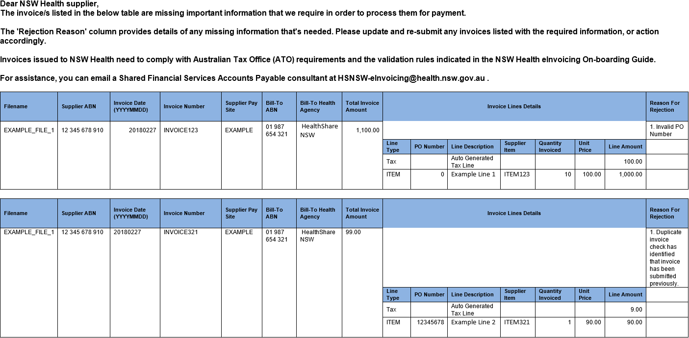

Implementation

Deactivation of Alternate Submission Methods
NSWH require suppliers to move to one submission channel. This will help reduce duplicate invoices which impacts re-work and invoices payments. To do this, the supplier must:

- have an agreed start day to submit via the Data Exchange Hub channel once connectivity and testing has successfully been completed
- fulfil the actions indication in Table 5.

Table 5
Review and implement; | Exceptions;
- A Delivery/Service Docket is to be provided with the goods and services. The words Invoice and Tax Invoice need to be removed from this docket.  - Deactivate all emails to NSWH containing invoices. This includes follow up or account inquiry emails. Your health facility contact can view your invoice electronically though the NSWH system.  - Check the status of outstanding invoices via the NSWH Supplier Portal prior to contacting the Accounts Payable department. | - Invoices for Pharmacies require a hardcopy to be delivered with the goods and services to the health facility.  - Invoices for Food Services require a hardcopy to be delivered with the goods and services to the health facility. These invoices can be identified by the ordering number which contains at least three alpha characters at the start (e.g. CAM13758).

Further Support
For support on the Direct Interface channel, see contact details in Table 6.

Table 6
Support Type | Contact Details
- General Support | NSWH eInvoicing Project Team  Joseph Hudson: 02 4041 7885  Kate Fleming 02 4041 7373  Email: HSNSW-eInvoicing@health.nsw.gov.au
- Technical Assistance | eHealth – FMIS Operations  Phone: 1300 28 55 33
- Pacific Commerce Support | Martin Ely  National Business Manager  Pacific Commerce Pty Ltd  Email: martin.eley@pacificcommerce.com.au  Level 8, 1 Chandos Street  St Leonards NSW 2065  Office: +61 2 9468 3333  Mobile: +61 (0)403 585 171

End of On-Boarding Guide

